# 

# ****OCTOBER 2025****

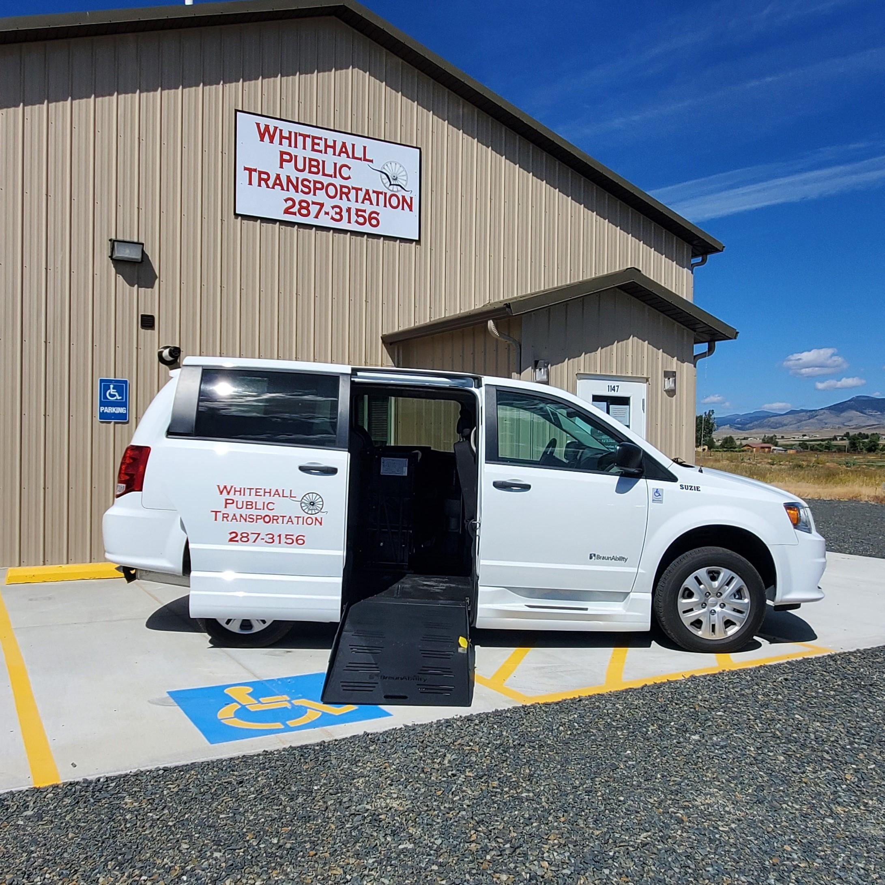 **Hours of Operation Monday-Friday 8:00 AM- 5:00 PM**

**We provide Local Shopping in Whitehall Every Tuesday— (a free service starting at 1:00 PM)**

|  |  |  |  |  |
| --- | --- | --- | --- | --- |
| Monday | Tuesday | Wednesday | Thursday | Friday |
| Pumpkin |  | 1) BUTTE- 9:00  Depart WH- 8:30  BUTTE- 2:30  BOZEMAN- 2:00  Depart WH- 12:40 pm | 2) BUTTE- 9:00  Depart WH- 8:30  BUTTE- 2:30  Depart WH- 1:40  BOZEMAN-10:30  Depart WH-9:15 | 3)  Country Store  Call for details |
| 6)  BUTTE- 9:00  Depart WH- 8:30  BUTTE- 1:30  Depart WH- 12:45 | 7)  BUTTE- 9:00  Depart WH- 8:30  BUTTE- 1:00-3:00  Depart WH- 12:45 | 8) BUTTE- 9:00  Depart WH- 8:30  BUTTE- 1:30  Depart WH- 12:45  Dillon-Missoula- 10:30 Depart WH-7:00 am | 9)  BUTTE- 9:00  Depart WH- 8:30  BUTTE- 2:30  Depart WH- 1:40 | 10) |
| 13)  BUTTE- 9:00  Depart WH- 8:30  BUTTE- 1:30-4:00  Depart WH- 12:45 | 14)  BUTTE- 9:00  Depart WH- 8:30  BUTTE- 1:00-3:00  Depart WH- 12:45 | 15)  BUTTE- 9:00  Depart WH- 8:30  BUTTE- 1:30  Depart WH- 12:45 | 16)  BUTTE- 9:00  Depart WH- 8:30  BUTTE- 2:30  Depart WH- 1:40 | 17)  Pumpkin |
| 20)  BUTTE- 9:00  Depart WH- 8:30  BUTTE- 1:30-4:00  Depart WH- 12:45 | 21)  BUTTE- 9:00  Depart WH- 8:30  BUTTE- 1:00-3:00  Depart WH- 12:45 | 22)  BUTTE- 9:00  Depart WH- 8:30  BUTTE- 1:30  Depart WH- 12:45 | 23)  BUTTE- 9:00  Depart WH- 8:30  BUTTE- 2:30  Depart WH- 1:40 | 24) |
| 27)  BUTTE- 9:00  Depart WH- 8:30  BUTTE- 1:30-4:00  Depart WH- 12:45 | 28)  BUTTE- 9:00  Depart WH- 8:30  BUTTE- 1:00-3:00  Depart WH- 12:45 | 29)  BUTTE- 9:00  Depart WH- 8:30  BUTTE- 1:30  Depart WH- 12:45 | 30)  BUTTE- 9:00  Depart WH- 8:30  BUTTE- 2:30  Depart WH- 1:40 | 31) |